**Name:** Sayyeda Asma

**Roll no:** 2019-ce-10

**Name:** Mariam Nasir

**Roll no:** 2019-ce-31

**Objective:** Recipe Website

**Project Title:** Recipex

**Description**

Recipex website will enable users to view their favorite recipes and see their YouTube links after

their account has been made .Admin of this website can update the already existing records

Insert a new record and delete record of recipes. user can search recipes

he/she can also see the records of users.

**Admin side**

Here are some of the features of the admin side

* First the admin has to login to his account with the email [sayyedaasma@gmail.com](mailto:sayyedaasma@gmail.com)
* And password:Asma123.
* Then he is redirected to admin page. if he enters any of the credential wrong, he /she will be given error
* For the front page I have used bootstrap, HTML CSS (div elements ).I have used arrays to ensure admin has logged in .

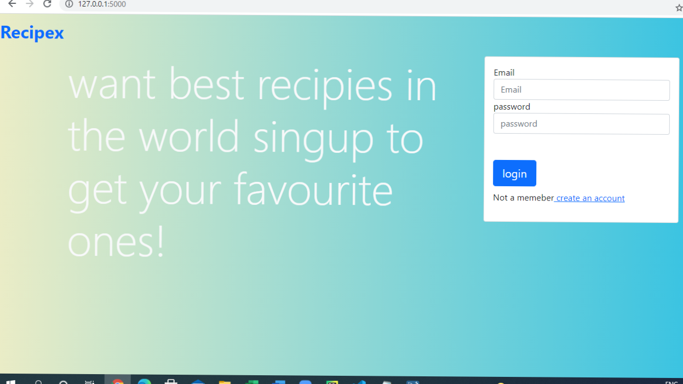

* So admin can see the front page of the website where various options are available for him.when loggin is successful . He can see user records which users have made their account on this website

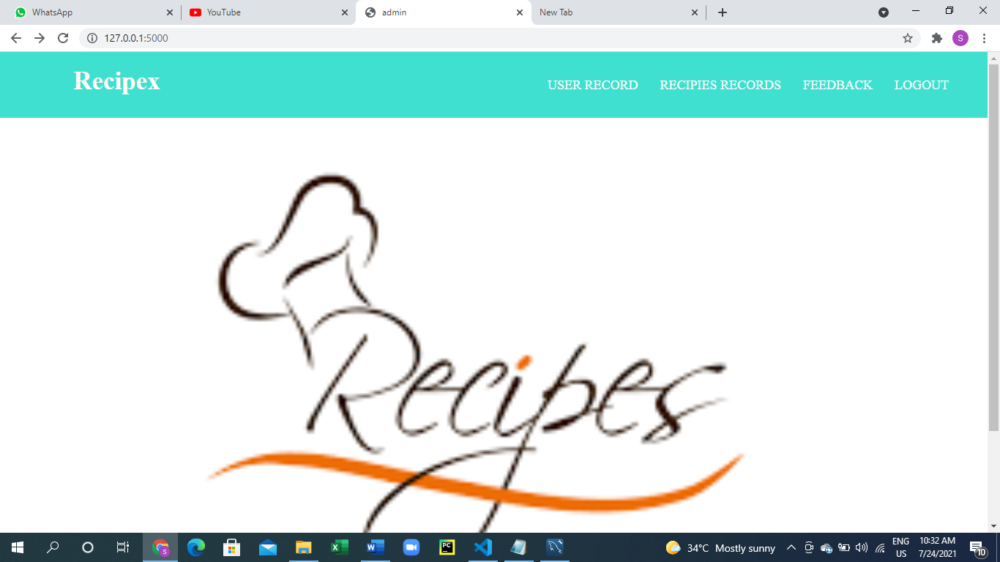

* If the user has no account then he she has to register first.
* Registration screen

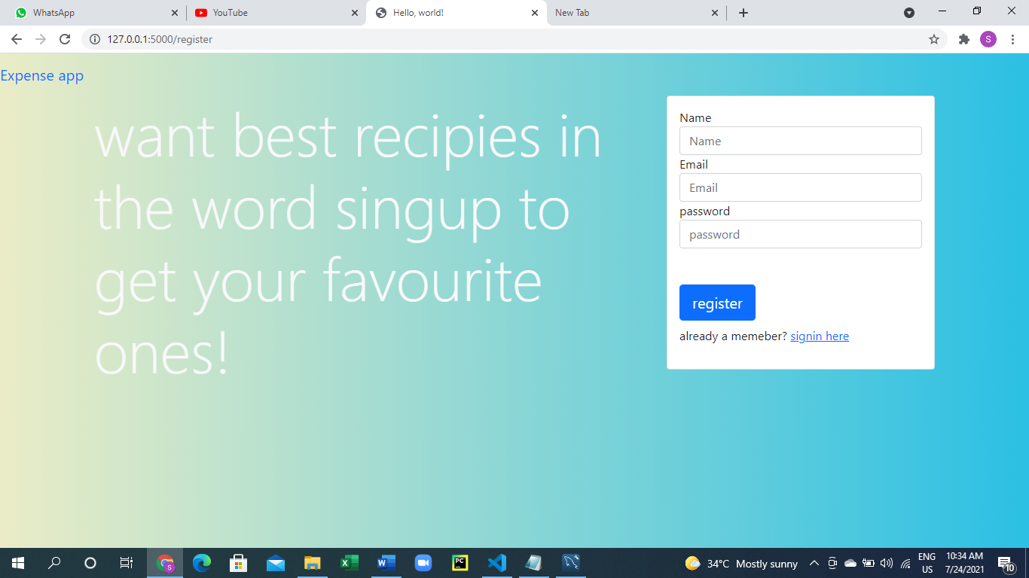

* So admin can see the front page of the website where various options are available for him.when loggin is successful . He can see user records (users who have made their account on this website ). I have used table element for the front page and for displaying data I have used sql queries.

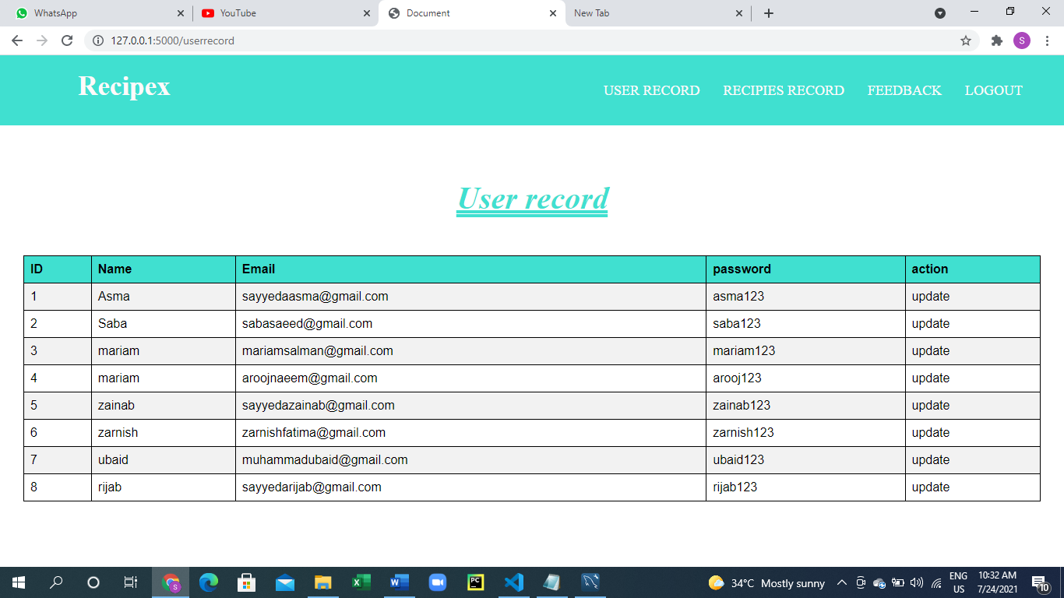

* User records contain the records of users who created their accounts on this website. Admin can see user’s information like email address, password.

Used SQL’s queries to display the data base of user’s on the front end. Use mySQLdb.cursors.

* Admin can see al the records of recepies he can insert a new record of recepie , update a new record of recepies and delete a new record of recepies .
* He can add images of recepies whose paths are stored in database and images in the static folder in the upload folder .
* All other categories of recepies have same table as shown .

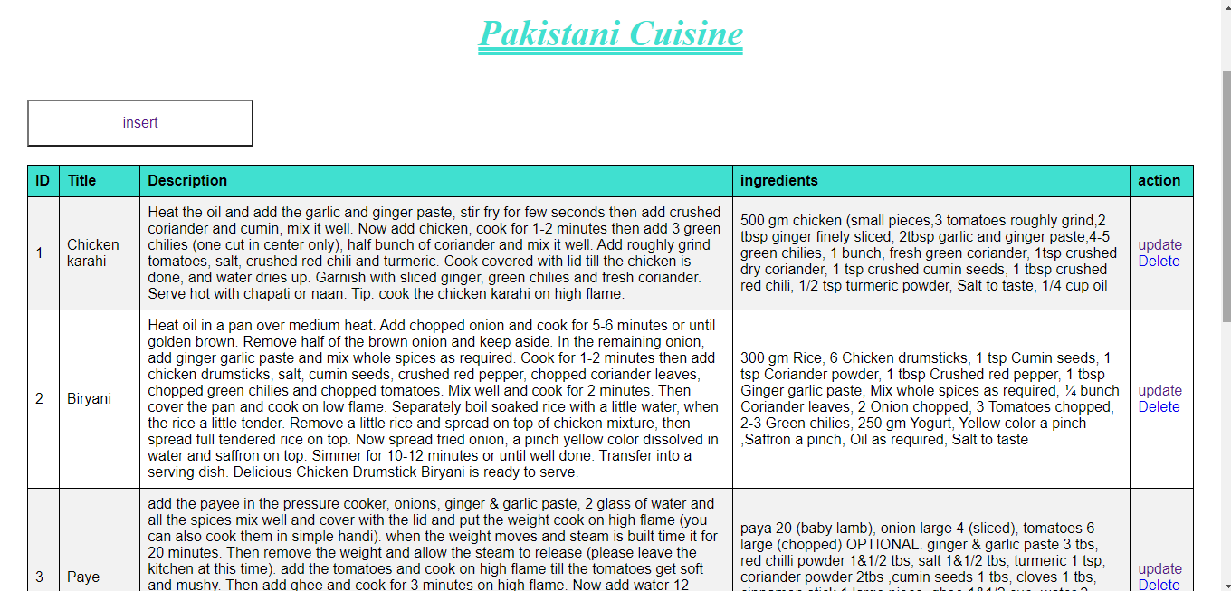

* Insert new record page is as follow.

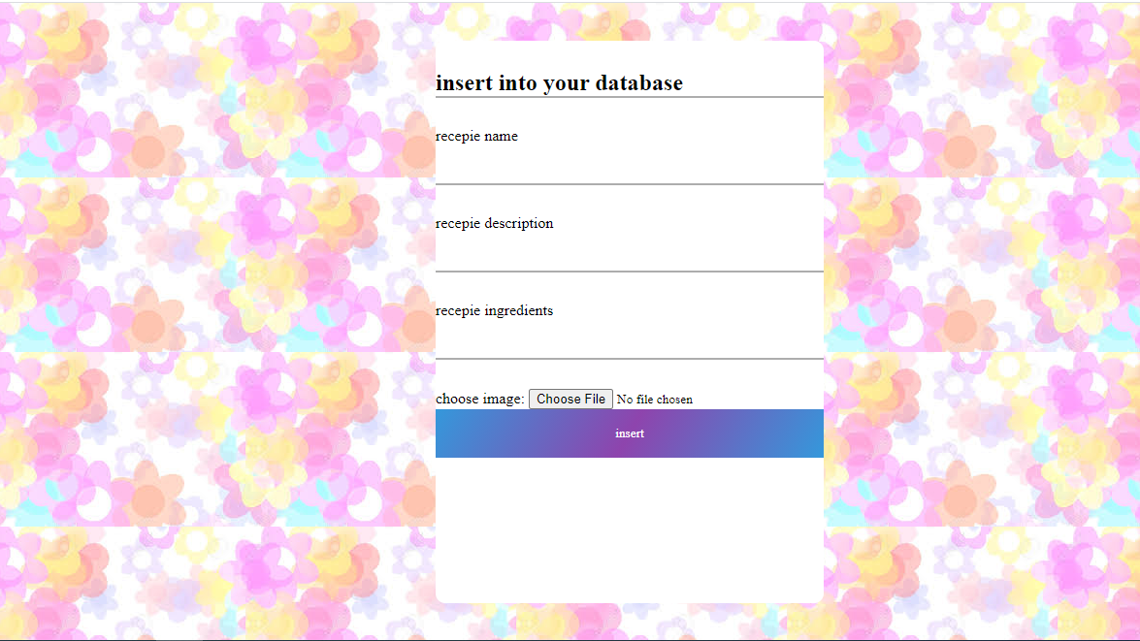

Update new records page:

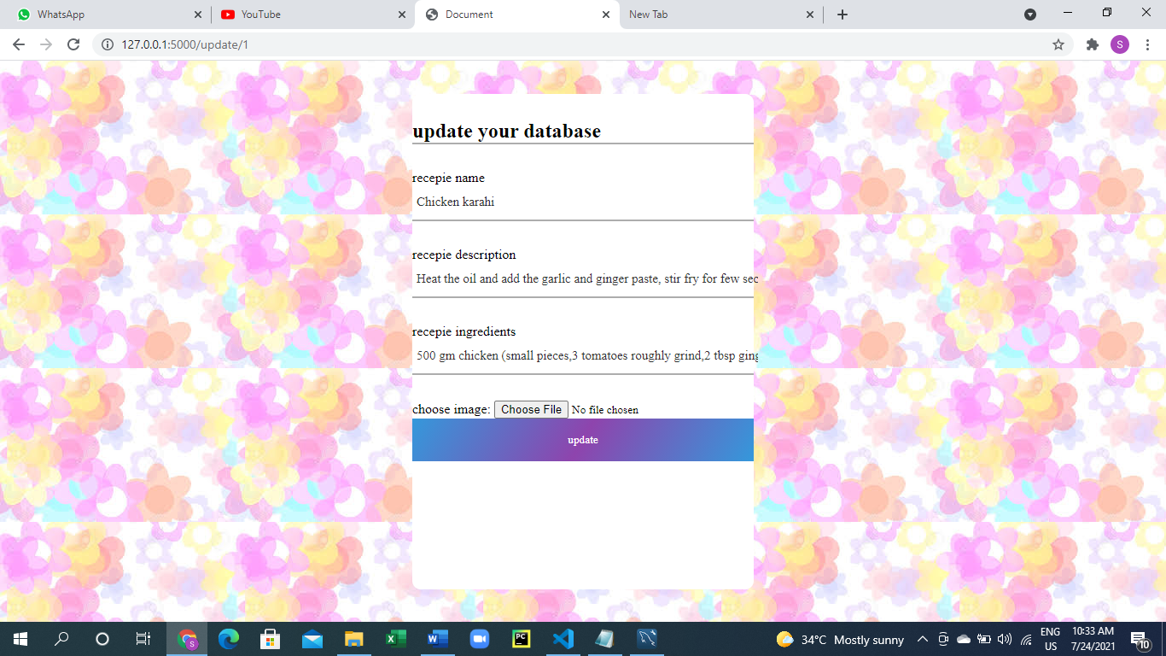

* After clicking the update button the admin is redirected to recepie records page
* When a user clicks the logout button he is redirected to login page

**User side :**

Both user and admin have same login page when user enter his/her credentials he she is

Redirected to user page

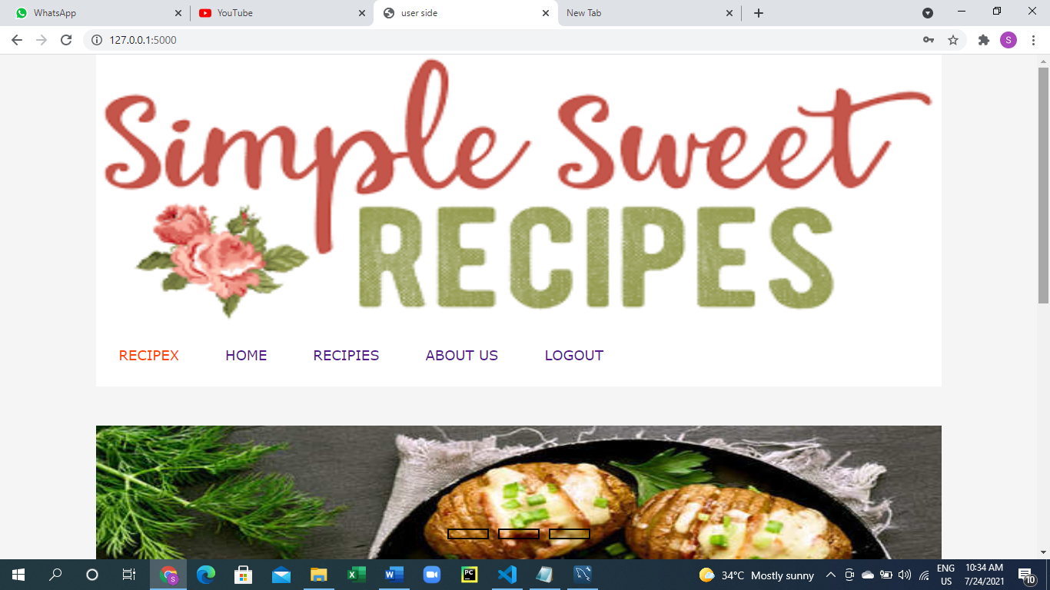

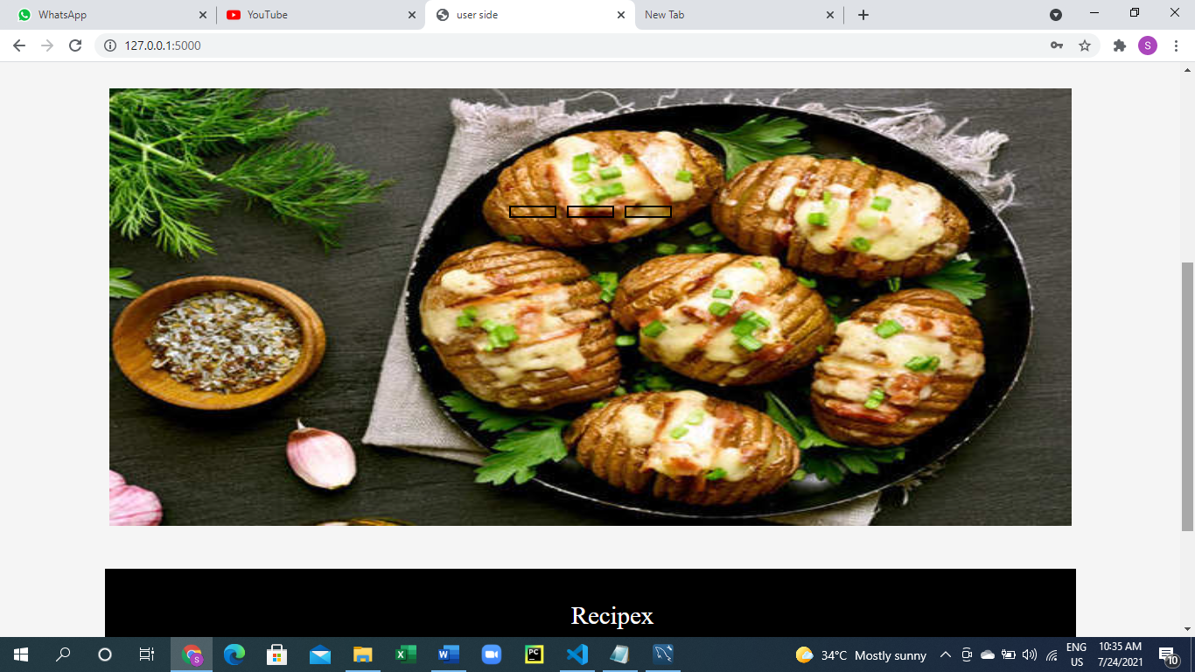

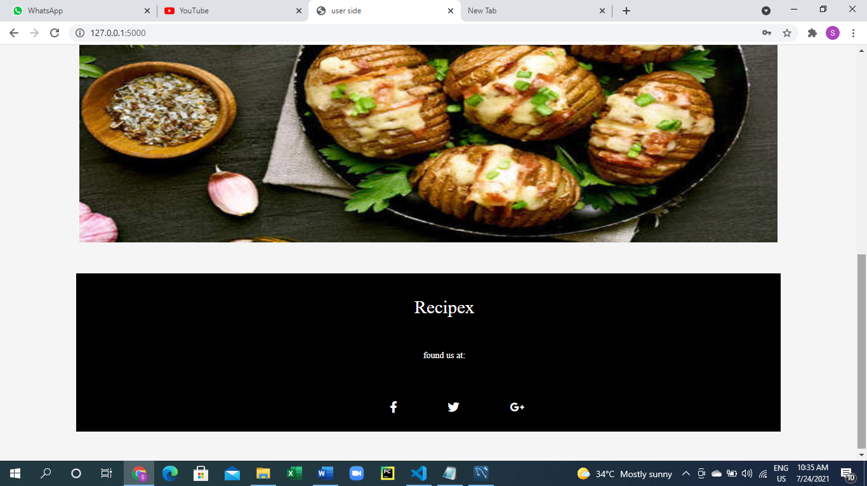

Used slideshow and footers to make user website beautiful and interactive.

When a user clicks home page he is redirected to user page

**About us :**

About us page shows contacts and info about admin

**Recipe button:**

On clicking recipe button user can see all categories available

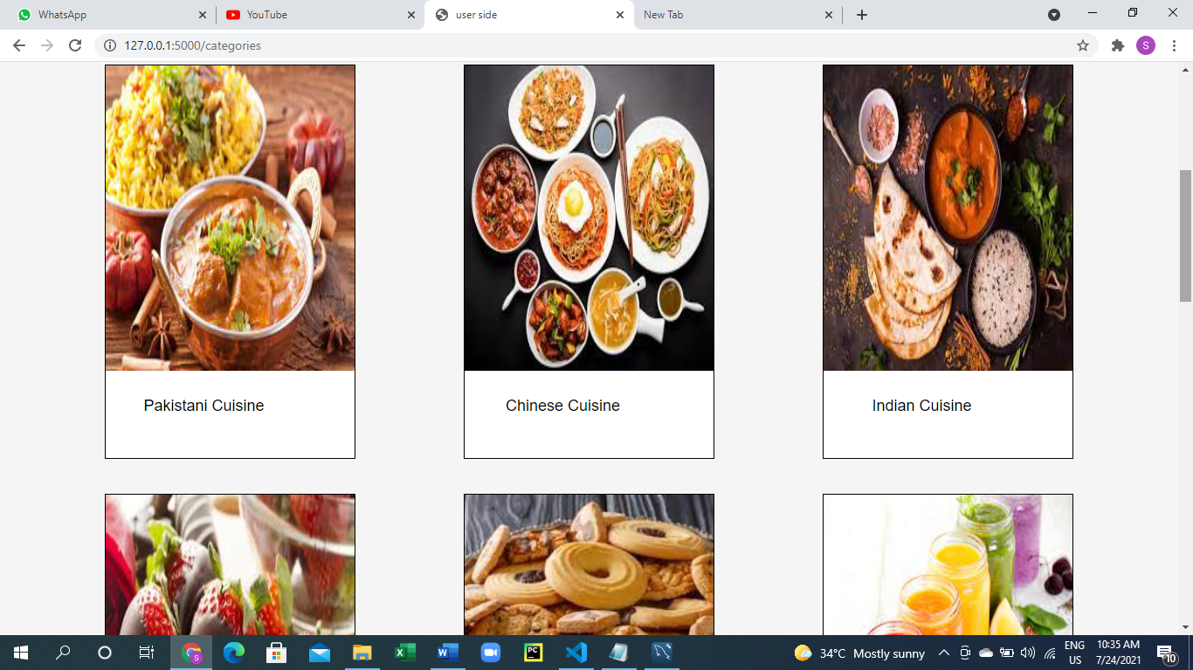

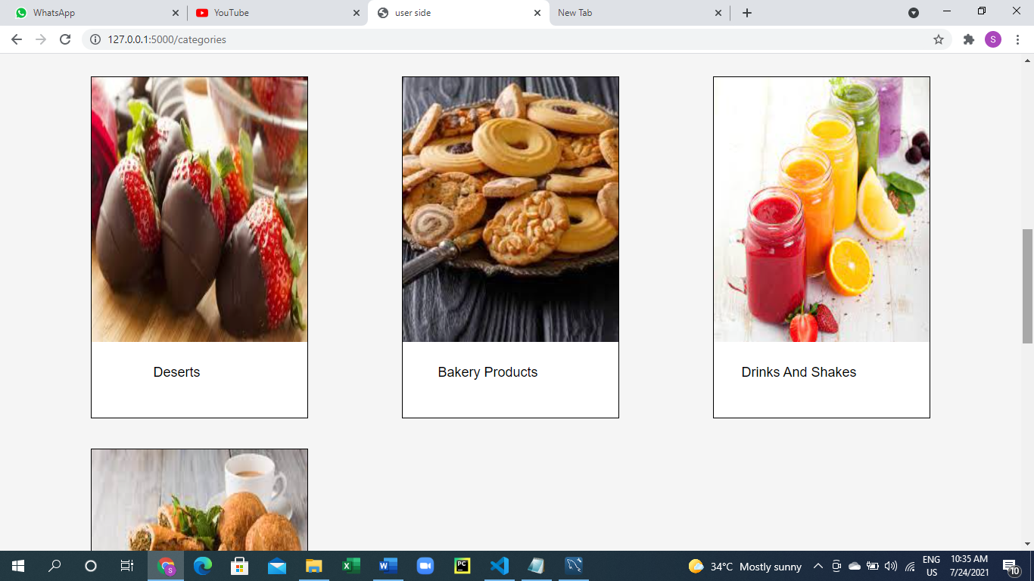

After clicking on categories user can see all the recopies available for categories.

Used HTML div categories.

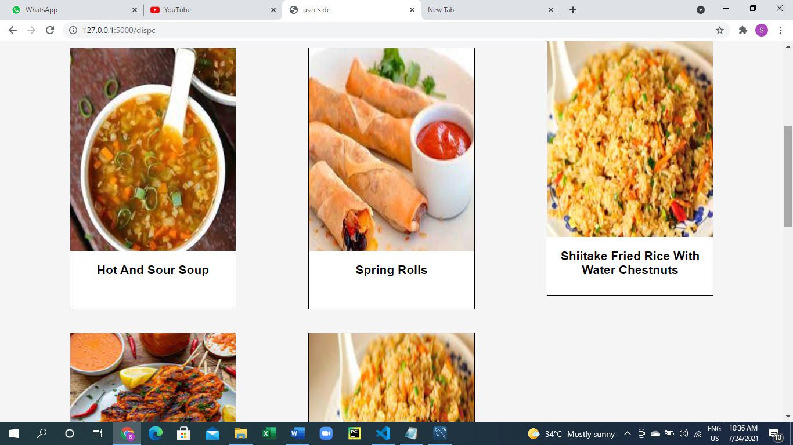

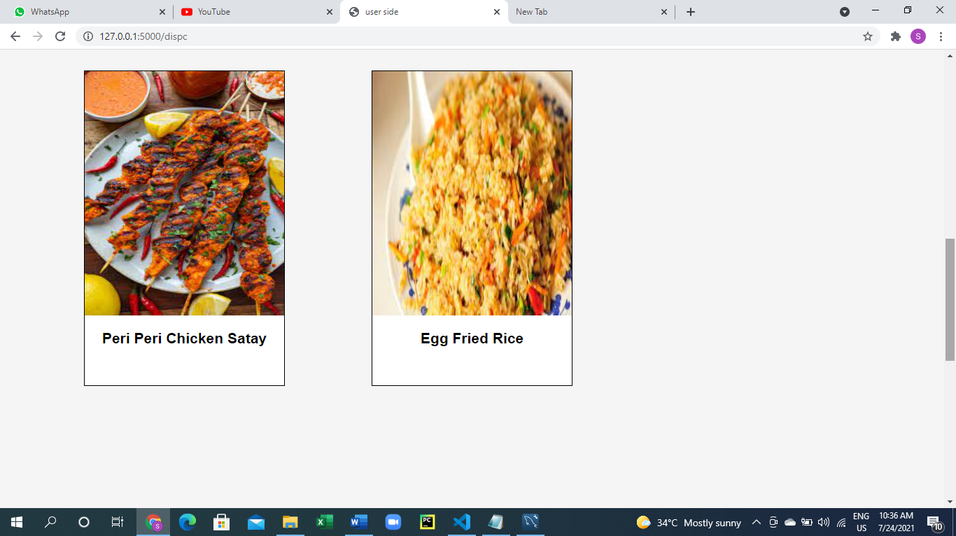

After clicking for categories

User can see the recipes just like this

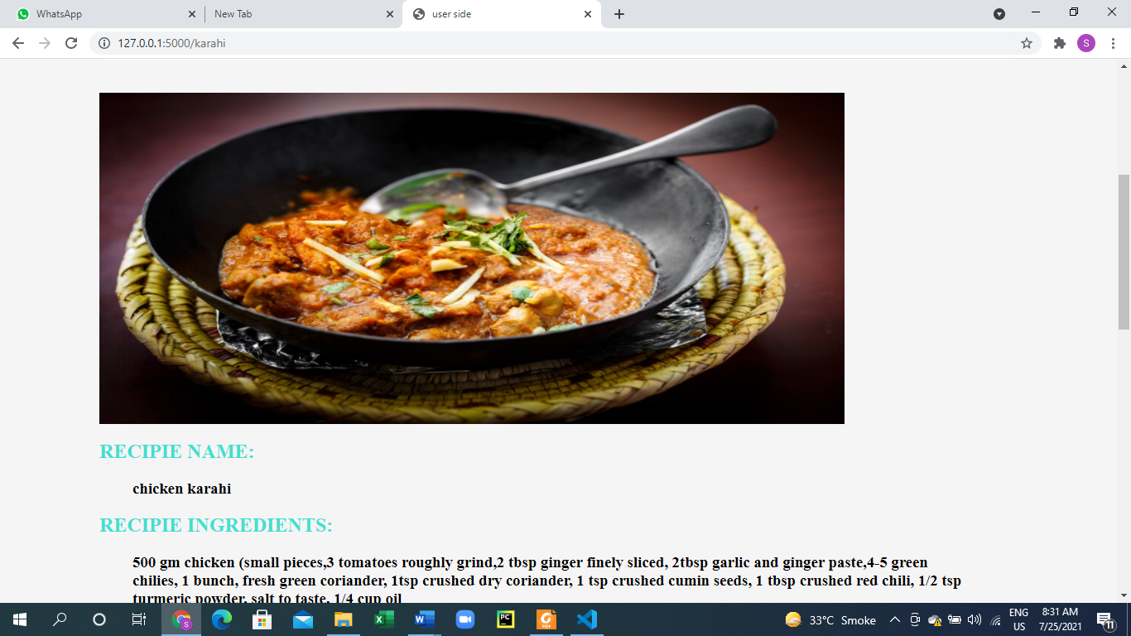

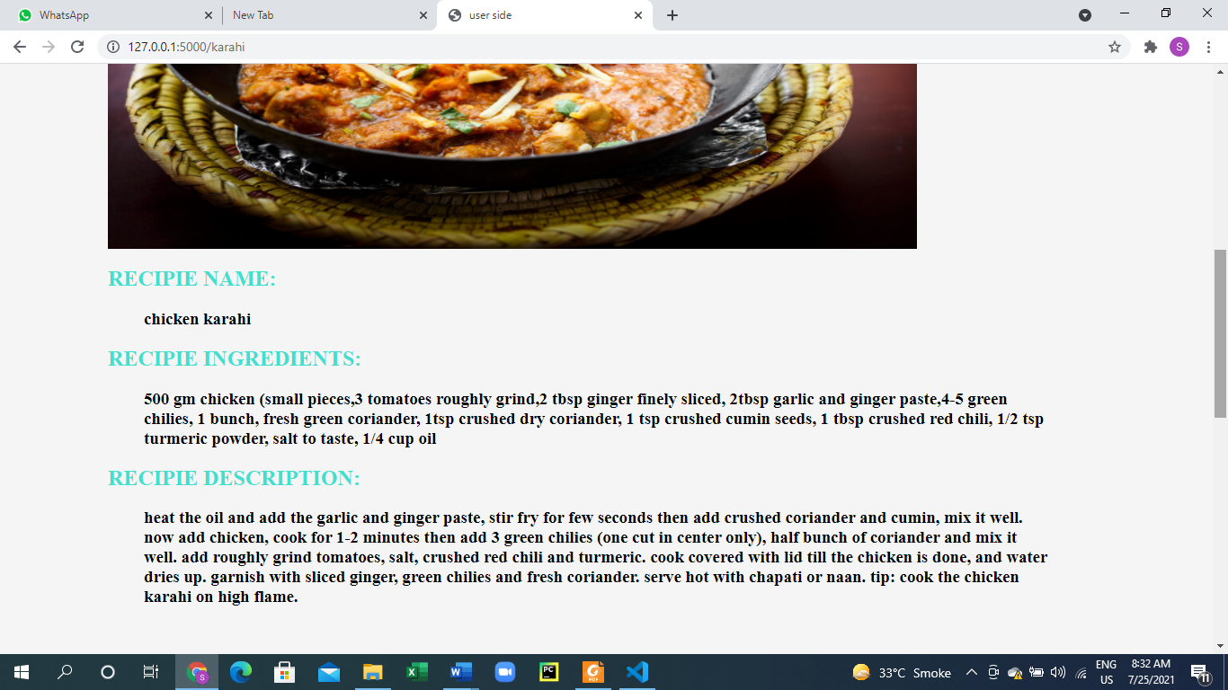

User can also see the YouTube links

**Data structures used:**

We’ve used **arrays.** The best reason to use arrays is that, they are best to use if for storing sessional variables. In our project we need to store sessional different sessional variables to make the available in different routes.

**Contribution:**

Both mariam and me do backened ,frontend mutually .

**PROJECT FLOW DIAGRAM:**

**Admin side:**

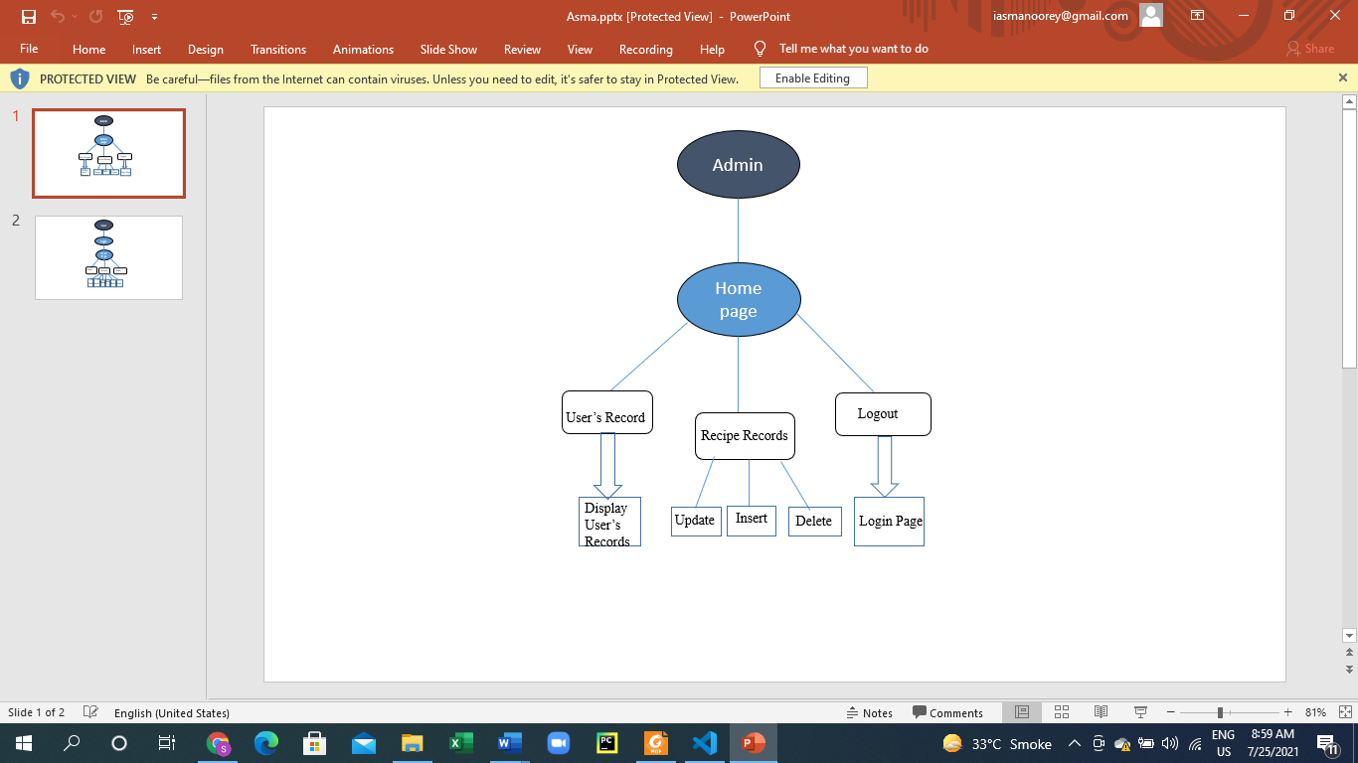

**User side:**

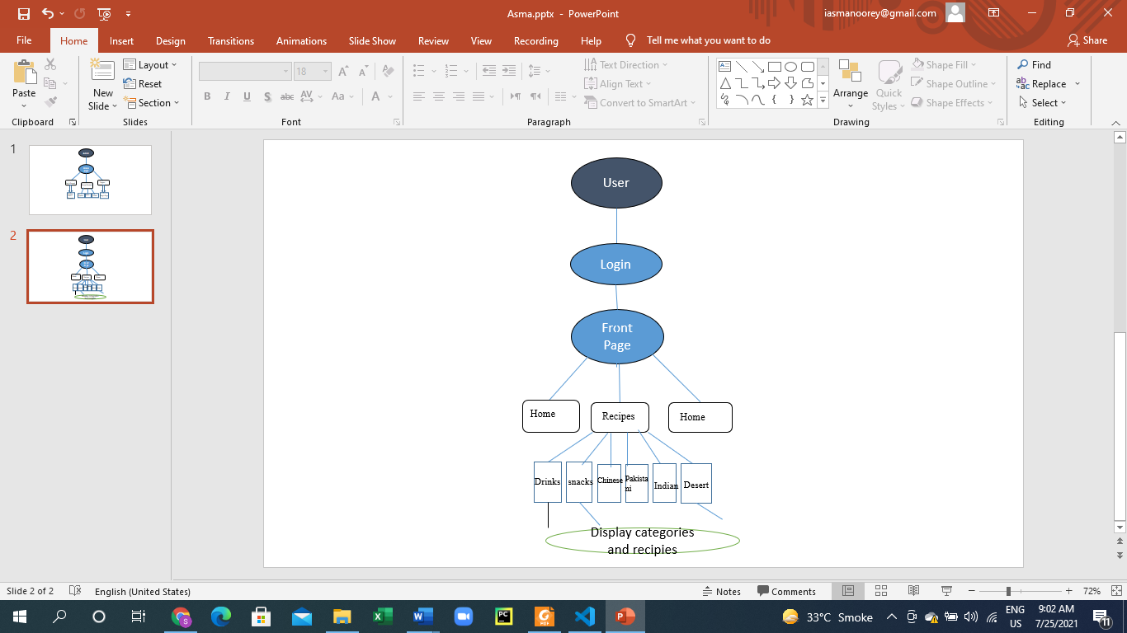

**Algorithm used:**

Binary search algorithm

**PROJECT REPOSITORY LINK:**

<https://gitlab.com/dsa-group1/recipex>

**Project requirements and configuration:**

Install VS code

Install flask by pip install flask

Python should be installed in your machine if not then install python 3.9.4 version

Create virtual environment in Vs code

Open all the folders in vs code Do not change the directories of any of file

Install jinja extension in the extension tab of vs code

Install MySQL dB package in vs code

Used HTML CSS, JavaScript and Bootstrap for this project

Open project folder in vs code

Use mysql workbench

Create instance of sql set your name and password

In the app.py file chane the sql credentials according to yours

In the vs code terminal type .\env\scripts\activate.ps1 then run

Python app.py

**CHALLENGES AND FUTURE WORK**

Overall, we didn’t face any special difficulty in applying things, but implementing comments and reviews in the code was challenging we tried a lot but it didn’t work.

**REFRENCES:**

* [**https://www.researchgate.net/publication/332524872_Food_Recipe_Finder_Mobile_Applications_Based_On_Similarity_Of_Materials**](https://www.researchgate.net/publication/332524872_Food_Recipe_Finder_Mobile_Applications_Based_On_Similarity_Of_Materials)
* [**https://www.researchgate.net/publication/332524872_Food_Recipe_Finder_Mobile_Applications_Based_On_Similarity_Of_Materials**](https://www.researchgate.net/publication/332524872_Food_Recipe_Finder_Mobile_Applications_Based_On_Similarity_Of_Materials)
* [**https://uxmag.com/articles/case-study-an-educational-cooking-app**](https://uxmag.com/articles/case-study-an-educational-cooking-app)
* [**https://www.irjet.net/archives/V5/i4/IRJET-V5I4327.pdf**](https://www.irjet.net/archives/V5/i4/IRJET-V5I4327.pdf)

[**http://ieeexplore.ieee.org/abstract/document/6986011/**](http://ieeexplore.ieee.org/abstract/document/6986011/)